A project report on

ANALYSIS AND FORECASTING OF INTERNATIONAL DEBT STATISTICS – A MACHINE LEARNING APPROACH

Submitted in partial fulfillment for the award of the degree of

Integrated M.Sc.

in

Computational Statistics and Data Analytics

by
S YASHUVANTHRA DHEVI (20MIY0007)

Under the guidance of
Dr. UDHAYAKUMAR R
Department of Mathematics
VIT, Vellore



SCHOOL OF ADVANCED SCIENCES
May, 2025
ANALYSIS AND FORECASTING OF INTERNATIONAL DEBT STATISTICS – A MACHINE LEARNING APPROACH

Submitted in partial fulfillment for the award of the degree of

Integrated M.Sc.
in

Computational Statistics and Data Analytics

by

S YASHUVANTHRA DHEVI (20MIY0007)

Under the guidance of

Dr. UDHAYAKUMAR R
Department of Mathematics
VIT, Vellore

SCHOOL OF ADVANCED SCIENCES
May, 2025
DECLARATION

I hereby declare that the thesis entitled "ANALYSIS AND FORECASTING OF INTERNATIONAL DEBT STATISTICS – A MACHINE LEARNING APPROACH" submitted by me, for the award of the degree of Integrated M.Sc. Computational Statistics and Data Analytics is a record of bonafide work carried out by me under the supervision of Dr. Udhayakumar R (Internal).
I further declare that the work reported in this thesis has not been submitted and will not be submitted, either in part or in full, for the award of any other degree or diploma in this institute or any other institute or university.

Place: Vellore
Date: 07/05/2025 Signature of the Candidate

CERTIFICATE
This is to certify that the thesis entitled "ANALYSIS AND FORECASTING OF INTERNATIONAL DEBT STATISTICS – A MACHINE LEARNING APPROACH" submitted by S YASHUVANTHRA DHEVI (20MIY0007), School of Advanced Sciences, Vellore Institute of Technology, Vellore for the award of the degree M.Sc. Computational Statistics and Data Analytics is a record of bonafide work carried out by her under my supervision.
The contents of this report have not been submitted and will not be submitted
either in part or in full, for the award of any other degree or diploma in this institute or
any other institute or university. The Project report fulfils the requirements and regulations of
VELLORE INSTITUTE OF TECHNOLOGY, VELLORE and in my opinion meets the necessary standards for submission.

Signature of the Guide Signature of the HoD

Internal Examiner External Examiner

ACKNOWLEDGEMENT

I extend my heartfelt gratitude to my guide Dr. Udhayakumar R (Internal) from the School of Advanced Sciences, VIT, Vellore, whose continuous encouragement and motivation were instrumental in the successful completion of this research.
I am deeply thankful to VIT, Vellore's Chancellor Dr. G. Viswanathan, the Vice Presidents, and the Vice Chancellor for providing the necessary infrastructure and resources to pursue my research at this esteemed institution.
I sincerely thank Dr. Karthikeyan K, Dean of the School of Advanced Sciences, for his supportive words and encouragement throughout this journey. My appreciation also goes to Dr. Jagadeesh Kumar M.S, Head of the Department of Mathematics, for his steady support and guidance.
The unwavering support of my parents has been my greatest strength throughout this academic endeavour. Their belief in my abilities and constant encouragement during challenging times have been crucial to my perseverance.
I also express my appreciation to my friends who have stood by me, offering both moral support and practical help whenever needed, making this journey both academically rewarding and personally fulfilling.

Place: Vellore
Date: 07/05/2025 S Yashuvanthra Dhevi

i
ABSTRACT
This study examines external debt to the World Bank by employing machine learning techniques. The research examines debt trends among nations from 1970 to 2023, specifically highlighting India, utilizing data obtained via the World Bank API. Following the preprocessing of the data to address missing values and guarantee stationarity, four forecasting models were applied: ARIMA, Random Forest, LSTM, and a combined ARIMA+LSTM model. The exploratory analysis indicated that China, Brazil, and Mexico rank as leading debtors worldwide. For India, important debt indicators comprised imports of goods and services, total external debt, and exports of goods and services. Time series analysis revealed considerable variations in debt, with prominent spikes around 2005 surpassing 30% year-over-year growth. Among the predictive models, the combined ARIMA+LSTM method showed better results with around 15% mean absolute percentage error. This integrated method successfully identified both linear and non-linear trends in debt growth. The research suggests applying this methodology to project debt for other nations and including additional economic factors such as GDP and inflation rates to enhance prediction precision. The knowledge acquired can guide the creation of more efficient debt restructuring systems, aiding in financial stability and fair development.

Keywords
Time Series Analysis, Machine Learning, Debt Forecasting, World Bank, External Debt, Financial Stability, Data Analytics, Predictive Modeling, Economic Indicators, Statistical Analysis

ii
TABLE OF CONTENTS

ACKNOWLEDGEMENT …………………………………………………………….. i
ABSTRACT ……………………………………………………………………………. ii
TABLE OF CONTENTS ……………………………………………………………… iii
LIST OF FIGURES ……………………………………………………………………. v
LIST OF TABLES ……………………………………………………………………... vi
LIST OF ABBREVIATIONS ………………………………………………………… vii
CHAPTER 1: INTRODUCTION
1.1 BACKGROUND 1
1.2 SIGNIFICANCE OF THE STUDY 2
1.3 RESEARCH OBJECTIVES 3
1.4 RESEARCH QUESTIONS 3
1.5 STRUCTURE OF THESIS 4
CHAPTER 2: LITERATURE SURVEY
2.1 SUMMARY OF EXISTING WORKS 5
2.2 RESEARCH GAP 11
CHAPTER 3: REQUIREMENTS
3.1 HARDWARE REQUIREMENTS 12
3.2 SOFTWARE REQUIREMENTS 12
CHAPTER 4: METHODOLOGY
4.1 DATA COLLECTION 13
4.2 DATA ANALYSIS AND PRE-PROCESSING 14
4.3 MODEL SELECTION AND IMPLEMENTATION 15
4.4 MODEL TRAINING AND EVALUATION

iii
CHAPTER 5: RESULTS AND DISCUSSIONS
5.1 EXPLORATORY DATA ANALYSIS
5.2 MODEL PERFORMANCE
5.3 DISCUSSIONS
CHAPTER 6: CONCLUSION AND RECOMMENDATIONS
6.1 CONCLUSION
6.2 DEBT FORECAST
6.3 RECOMMENDATIONS
REFERENCES ………………………………………………………………..viii

iv
LIST OF FIGURES
4.1 METHODOLOGY FLOWCHART 13
4.2 ARIMA MODEL WORKFLOW 15
4.3 RF MODEL WORKFLOW 17
4.4 LSTM MODEL WORKFLOW 18
4.5 ARIMA+LSTM MODEL WORKFLOW 20
5.1 DEBT TREND 24
5.2 TOP 10 DEBTORS 24
5.3 TOP 10 DEBTORS TREND 24
5.4 TOP 5 DEBT INDICATORS 25
5.5 DEBT TREND OF INDIA 26
5.6 DEBT DISTRIBUTION OF INDIA 26
5.7 YEAR-OVER-YEAR % DEBT CHANGE 26
5.8 ARIMA PREDICTION 28
5.9 RF PREDICTION 28
5.10 LSTM PREDICTION 29
5.11 ARIMA+LSTM PREDICTION 29
5.12 ARIMA RESIDUALS 31
5.13 RF RESIDUALS 31
5.14 LSTM RESIDUALS 32
5.15 ARIMA+LSTM RESIDUALS 32
6.1 10 YEARS DEBT FORECAST 36

v
LIST OF TABLES
2.1 LITERATURE SURVEY 7
4.1 EVALUATION METRICS 23
5.1 MODEL EVALUATION 27
6.1 MODEL COMPARATIVE ANALYSIS 35
6.2 10 YEARS DEBT FORECAST 36

vi
LIST OF ABBREVIATIONS

ADF Augmented Dickey-Fuller
AIC Akaike Information Criterion
API Application Programming Interface
ARIMA Autoregressive Integrated Moving Average
BIC Bayesian Information Criterion
DL Deep Learning
DRS Debtor Reporting System
GDP Gross Domestic Product
GRU Gated Recurrent Unit
IDS International Debt Statistics
IMF International Monetary Fund
LSTM Long Short-Term Memory
MAE Mean Absolute Error
MAPE Mean Absolute Percentage Error
ML Machine Learning
MSE Mean Squared Error
RF Random Forest
RMSE Root Mean Squared Error
RNN Recurrent Neural Network
SARIMA Seasonal Autoregressive Integrated Moving Average
SVM Support Vector Machine

vii
CHAPTER 1
INTRODUCTION

  - BACKGROUND
International debt, commonly known as external debt, signifies the aggregate sum of money that a nation owes to creditors outside its borders. These external loans are used for a range of developmental activities, which include infrastructure improvements, health care programs, educational systems, and other socio-economic enhancements. The entities offering these loans consist of foreign governments, international bodies like the World Bank and International Monetary Fund (IMF), private financial organizations, and overseas investors. The IMF, which is accountable to its 190 member nations, and the World Bank, which aims to eradicate extreme poverty while fostering shared prosperity, are two pivotal international institutions that provide financial support to countries in need. The IMF is concerned with ensuring stability in the global monetary system, whereas the World Bank focuses on granting loans and aid to the governments of low- and middle-income nations for developmental projects. To systematically monitor and analyze the external debt of nations, the World Bank utilizes the Debtor Reporting System (DRS). This mechanism collects and archives debt reports from various countries within the World Bank’s Data Bank. The Data Bank serves as a comprehensive repository of databases, which includes the International Debt Statistics (IDS) and World Development Indicators (WDI), offering essential information for economic assessment and policy formulation. The IDS database provides in-depth details regarding external debt, such as the name of the country (debtor), the type of debt (debt indicator), and the total debt amount. This structured information facilitates a thorough analysis of debt trends and patterns across diverse nations and time frames. By utilizing this data, insights can be gained into the economic stability of countries and future debt scenarios can be predicted, thus informing policy decisions and economic strategies.
Machine learning methodologies present robust tools for analyzing and predicting time series data like external debt. Traditional statistical techniques, such as Autoregressive Integrated Moving Average (ARIMA), have been commonly employed for time series predictions, yet they possess limitations in identifying intricate non-linear patterns. Machine learning algorithms such as Random Forest (RF) and deep learning architectures like Long Short-Term Memory (LSTM) networks have demonstrated promising outcomes in addressing non-linear relationships and long-term dependencies present in time series data. Furthermore, hybrid methodologies that merge statistical and machine learning approaches may provide improved forecasting capabilities by exploiting the advantages of both methods. This study utilizes these advanced analytical methods to investigate international debt statistics, with a specific emphasis on India's external debt, aiming to understand historical trends and predict future developments.
1
  - SIGNIFICANCE OF THE STUDY
The importance of examining international debt statistics goes well beyond mere academic curiosity, as it carries significant implications for economic stability, policy development, and the general welfare of nations. The rise in external debt has immediate effects on a country's fiscal condition and growth potential.
As a nation's external debt grows, it results in increased debt servicing responsibilities, which include both principal repayments and interest payments. For Less Economically Developed Countries (LEDCs), which often depend heavily on external borrowing for their development needs, these obligations can become particularly overwhelming. As the demands of debt servicing escalate, governments may have to face tough decisions between sustaining critical social services such as healthcare and education or fulfilling their debt commitments. In severe scenarios, countries might default on their debt repayments, which can jeopardize relationships with creditors and possibly result in economic isolation. Examining debt data lays the groundwork for comprehending historical trends and the potential consequences of prolonged debt accumulation. By recognizing trends and correlations in debt statistics, it is feasible to evaluate the sustainability of current debt levels and to project future debt scenarios. This understanding is vital for averting debt crises and for crafting economic strategies that foster growth and stability.
Moreover, given the global economic interdependence, the debt circumstances of one nation can trigger repercussions throughout the entire international financial system. Thus, precise predictions of debt trends are pertinent not only for individual countries but also for the wider global economic landscape. Utilizing machine learning methods in debt analysis signifies a major leap forward in this area. Conventional statistical techniques may not adequately capture the intricate dynamics of debt accumulation and servicing, particularly in fluctuating economic situations. Machine learning algorithms, known for their capability to discover complex patterns and relationships within data, provide the possibility for enhanced forecasting accuracy and more profound insights.
This study, concentrating on the analysis and forecasting of international debt through machine learning methods, enriches the existing knowledge base by establishing a methodological framework applicable across various nations and economic situations. The particular emphasis on India’s external debt presents valuable insights for one of the world's largest economies, which may have significant implications for policy-making and economic strategies within the country. By integrating historical analysis with forward-looking projections, this research seeks to offer a holistic view of international debt dynamics, thereby aiding in more informed economic decisions and potentially leading to more stable and sustainable debt management practices on a global scale.
2
  - RESEARCH OBJECTIVES
The main goal of this research is to examine international debt data and create precise forecasting models utilizing machine learning methods.
The specific aims of this study are:
- To investigate the various categories of debt held by different nations: This aim includes analyzing the different forms of external debt among countries to uncover patterns and comparative standings.
- To determine the various debt indicators that influence a country’s crisis or recovery: This aim focuses on identifying which specific debt metrics significantly affect a nation’s economic well-being.
- To project future international debt: The third aim revolves around creating predictive models that can accurately estimate upcoming external debt levels.

  - RESEARCH QUESTIONS
In order to meet the objectives outlined previously, this research aims to address the following specific inquiries:
- What trends exist regarding debt accumulation over time?
- What is the aggregate amount of debt that countries are responsible for?
- Which nation carries the largest debt burden?
- What are the various debt indicators available?
- What is the average debt amount owed by countries according to different debt indicators?
- What is the highest amount due for principal repayment?
These inquiries are explored using statistical tools and machine learning methodologies applied to international debt data, with an emphasis on India's external debt. This analysis not only responds to these particular questions but also enhances the overall understanding of debt dynamics and forecasting techniques.

3
  - STRUCTURE OF THESIS
This thesis comprises six chapters, each focusing on distinct elements of the research:
Chapter 1: Introduction - This chapter offers a background on international debt, highlights the importance of examining debt statistics, delineates the research objectives, and articulates the specific research questions that frame this study.
Chapter 2: Literature Review - This chapter reviews the existing literature on time series analysis for debt forecasting, explores applications of machine learning in financial forecasting, discusses hybrid models for economic predictions, addresses technical debt in machine learning systems, and investigates the correlation between external debt and economic growth. It also pinpoints the research gap that this study intends to fill.
Chapter 3: Requirements – This chapter mentions the hardware and software used for completing the research successfully.
Chapter 4: Methodology - This chapter outlines the research methodology, detailing the procedures for data collection, the techniques for data analysis, and the four forecasting methods utilized: ARIMA, Random Forest, LSTM, and the hybrid ARIMA+LSTM model. It further explains the evaluation metrics employed to measure model performance.
Chapter 5: Results and Discussion - This chapter showcases the outcomes of the exploratory data analysis and evaluates the performance of the forecasting models. It encompasses global debt trends, an analysis of the leading debtor nations, a thorough exploration of India's debt situation, and a comparative study of the four forecasting models. Additionally, it provides a 10-year projection of India's external debt using the most effective model.
Chapter 6: Conclusion and Recommendations - This chapter encapsulates the principal findings of the research, considers their theoretical and practical implications, acknowledges the study's limitations, and offers suggestions for future research endeavours.
The thesis ends with a detailed reference list and appendices that contain the Python code used for data collection, analysis, and the execution of the four forecasting models.

4
CHAPTER 2
LITERATURE SURVEY

2.1 SUMMARY OF EXISTING WORKS
[1]Zhuravka et al. (2021) carried out research on the evaluation and prediction of state debt through time series analysis. Their work concentrated on assessing the persistence level and forecasting Ukraine's national debt from 2004 to 2020. Utilizing EViews software, they developed autoregressive and ARIMA models, with the ARIMA(1,1,4) model yielding the best outcomes, achieving a Mean Absolute Percentage Error (MAPE) of 11.8%. This investigation illustrates the capability of ARIMA models in capturing debt dynamics and delivering precise forecasts within a specific country context. In a related study, Keraro et al. (2024) concentrated on estimating Kenya's public debt using time series methodology. Their research aimed to identify the most suitable forecasting model for predicting the future of Kenya's public debt. Their results indicated that both ARIMA(0,2,1) and the Holt-Winters methods were effective models, with MAPE results of 1.1% and 1.3%, respectively. This research further emphasizes the relevance of ARIMA models in debt forecasting, particularly in developing nations. Athey and Imbens (2019) highlighted various machine learning techniques that economists should consider, including Generative Adversarial Networks, Reinforcement Learning, and Experimental Designs. They stressed the significance of regularization and hyperparameter tuning to avoid overfitting, a common issue when applying machine learning to economic datasets. Takawira (2024) assessed the forecasting performance of machine learning algorithms in comparison to logistic regression for predicting sovereign debt ratings. The study analyzed 14 different machine learning techniques and discovered they provided greater accuracy and outperformed traditional statistical methods. Nonetheless, the research also pointed out that the effectiveness of these methods may be limited by the specific data used. In the arena of exchange rate forecasting, Plakandaras et al. (2015) proposed an innovative model that breaks down price series into smooth and fluctuating components using ensemble empirical mode decomposition. This model subsequently applies multivariate adaptive regression splines for variable selection before employing support vector machines for predictions. Their approach exhibited superior forecasting effectiveness compared to other methods, challenging the efficient market hypothesis in foreign exchange arenas. Emerson et al. (2019) conducted a review of the trends and applications of machine learning in quantitative finance, concentrating on return forecasting, risk assessment, and portfolio development. They recognized that quantitative investing is leading the embrace of these new techniques within the financial sector, indicating an increasing acknowledgment of their benefits in financial analysis and prediction.

5
Lama et al. (2024) detailed the process of developing a hybrid approach that combines statistical methods with machine learning models, specifically ARIMA-LSTM and Random Forest. Their findings indicated that such combinations hold greater promise than individual statistical models, as they can effectively capture both linear and non-linear trends in the data. In the area of debt management, Zahariev et al. (2020) utilized Support Vector Machines to assess debt management practices in Italy and Greece. Their study revealed a significant correlation between various economic metrics and debt ratios in these nations, illustrating how machine learning methods can be employed to analyze debt dynamics in specific country contexts. Likewise, Rustam and Diani (2019) used Support Vector Regression to evaluate Indonesia's private external debt. Their research concentrated on corporate entities that borrow substantial sums for developmental purposes. The analysis indicated that Support Vector Regression offers a more precise examination of factors impacting corporate performance than conventional panel data regression methods, leading to suggestions for firms to reduce foreign debt and imports while boosting exports. Sculley et al. (2015) cautioned against the assumption that machine learning frameworks for developing intricate prediction systems come without their own costs. Through the concept of technical debt, they identified that real-world machine learning systems typically incur substantial ongoing maintenance expenses. Tsintzira et al. (2020) investigated the role of machine learning in Technical Debt Management (TDM), looking at how machine learning has been applied to a wider range of software engineering challenges. Their purpose was to uncover possibilities for enhancing technical debt management via machine learning technologies, proposing potential synergies between these fields. Albuquerque et al. (2022) performed a systematic mapping study on employing intelligent techniques to aid in Technical Debt Management. They emphasized the use of Machine Learning, Reasoning Under Uncertainty, and Natural Language Processing techniques in TDM activities from 2010 to 2020. Although their results indicated positive trends in application, especially concerning the identification, measurement, and monitoring of design, code, and architectural debt, they acknowledged that the field remains in its infancy. Huang et al. (2021) specifically addressed hidden technical debts related to fair machine learning in the financial sector. Their study focused on critical stages such as data preparation, model development, and system oversight, recommending measures to mitigate bias and maintain fairness throughout the lifecycle of machine learning systems. Chowdhury (2001) employed regression and sensitivity analysis to examine this link. The findings demonstrated that the association between various debt measures and economic growth remains strong across two categories of countries—Heavily Indebted Poor Countries (HIPC) and non-HIPC nations. This research emphasizes the necessity of taking into account country-specific circumstances when evaluating debt trends.

6
In the banking sector, Leo et al. (2019) assessed the implementation of machine learning in managing banking risks such as credit, market, operational, and liquidity risks. Their results indicated that there are numerous areas within bank risk management that could greatly benefit from machine learning interventions to tackle particular challenges, pointing out unexplored opportunities in this field. Anand et al. (2022) concentrated on forecasting loan behavior using machine learning models for safer banking practices. Their research analyzed multiple machine learning techniques for predicting loan defaults, including regression, decision trees, random forests, and Support Vector Machines. The outcomes indicated that the Extra Trees Classifier and Random Forest produced the highest accuracy, providing effective means for pinpointing at-risk consumers whose loan applications should be rejected. Zhang and Zheng (2022) established a thorough debt risk assessment framework for local governments in China, uncovering rapidly escalating debt threats with unique regional characteristics. Their machine learning-based early warning system achieved an accuracy rate of 92% in forecasting future debt risk levels, surpassing traditional debt risk measures.
TABLE 2.1: LITERATURE SURVEY
Sr. No. | Title | Author(s) | Year | Software/Model Used | Limitations
1 | Forecasting Kenya's public debt using time series analysis | Keraro et al. | 2024 | ARIMA(0,2,1), Holt-Winters | Country-specific analysis; May not generalize to other economies
2 | Comparing The Prediction Performance Of Machine Learning Algorithms Against The Logistic Regression Model In Forecasting Sovereign Debt Ratings | Takawira | 2024 | 14 different ML techniques vs. logistic regression | Effectiveness limited by specific data used

7
Sr. No. | Title | Author(s) | Year | Software/Model Used | Limitations
3 | Python code for modelling ARIMA-LSTM architecture with random forest algorithm | Lama et al. | 2024 | ARIMA-LSTM, Random Forest | CNN, GRU may be more optimal with RF
4 | Local Government Debt Risk Assessment and Early Warning Local Government Debt Risk Assessment and Early Warning System Based On Machine Learning | Zhang & Zheng | 2022 | Machine learning-based early warning system | Limited to Chinese local governments; Specific regional characteristics
5 | Prediction of Loan Behaviour with Machine Learning Models for Secure Banking | Anand et al. | 2022 | Regression, decision trees, random forests, SVMs, Extra Trees Classifier | Focused on loan defaults, not sovereign debt
6 | Comprehending the Use of Intelligent Techniques to Support Technical Debt Management | Albuquerque et al. | 2022 | ML, Reasoning Under Uncertainty, NLP | Field in its infancy; Technical rather than financial debt

8
Sr. No. | Title | Author(s) | Year | Software/Model Used | Limitations
7 | State Debt Assessment and Forecasting: Time Series Analysis | Zhuravka et al. | 2021 | EViews, ARIMA(1,1,4) | MAPE of 11.8%; Limited to Ukraine's national debt from 2004-2020
8 | Hidden Technical Debts for Fair Machine Learning in Financial Services | Huang et al. | 2021 | Various ML techniques | Conceptual; Focused on bias and fairness rather than prediction
9 | Debt management evaluation through Support Vector Machines: on the example of Italy and Greece | Zahariev et al. | 2020 | Support Vector Machines | Limited to Italy and Greece; Focused on correlation analysis rather than prediction
10 | Applying Machine Learning in Technical Debt Management: Future Opportunities and Challenges | Tsintzira et al. | 2020 | Various ML techniques | Conceptual exploration; Not focused on financial debt

9
Sr. No. | Title | Author(s) | Year | Software/Model Used | Limitations
11 | Machine Learning Techniques for Economists | Athey & Imbens | 2019 | GANs, Reinforcement Learning, Experimental Designs | Highlighted overfitting issues with economic datasets; No specific debt analysis
12 | Machine Learning Methods That Economists Should Know About | Emerson et al. | 2019 | Various ML techniques for return forecasting, risk assessment | Review paper; No primary research on debt specifically
13 | Support Vector Regression Implementation for Indonesian Private External Debt Analysis | Rustam & Diani | 2019 | Support Vector Regression | Limited to corporate entities in Indonesia
14 | Machine Learning in Banking Risk Management: A Literature Review | Leo et al. | 2019 | Various ML techniques | Assessment of implementation rather than results; General risk focus
15 | Hidden Technical Debt in Machine Learning Systems | Sculley et al. | 2015 | N/A (conceptual paper) | Focused on maintenance costs of ML systems, not financial debt

10
Sr. No. | Title | Author(s) | Year | Software/Model Used | Limitations
16 | Forecasting Daily and Monthly Exchange Rates with Machine Learning Techniques | Plakandaras et al. | 2015 | Ensemble empirical mode decomposition, multivariate adaptive regression splines, SVMs | Focused only on exchange rates, not directly on debt
17 | External Debt and Growth in Developing Countries: A Sensitivity and Causal Analysis | Chowdhury | 2001 | Regression, sensitivity analysis | Older study; Focused on relationship rather than prediction

2.2 RESEARCH GAP
The current body of literature offers useful perspectives on debt analysis and forecasting; however, several shortcomings persist:
- Inadequate Use of Hybrid Models: Despite the research by Lama et al. (2024), which has investigated hybrid models' potential, there is a scarcity of studies applying these methods to international debt forecasting.
- Emphasis on Individual Countries: A substantial amount of research concentrates on single countries (Zhuravka et al., 2021; Keraro et al., 2024; Zahariev et al., 2020; Rustam and Diani, 2019), with comparatively little focus on cross-country or regional comparisons.
- Insufficient Long-term Forecasting: Research on long-term debt forecasting is limited, particularly in relation to machine learning methods, which could yield important insights for strategic planning.
By addressing these deficiencies, this research enhances the current understanding of debt analysis and forecasting, delivering methodological improvements and practical guidance for policymakers and economic strategists.
11
CHAPTER 3
REQUIREMENTS

3.1 HARDWARE REQUIREMENTS
CPU: Modern multi-core processor (4+ cores)
RAM: 8GB minimum, 16GB recommended
Storage: 256GB SSD (faster data loading and processing)
GPU: Mid-range GPU (helpful for DL models if included)

3.2 SOFTWARE REQUIREMENTS
Core Tools:
- Python (3.8 or newer)
- VS Code as primary IDE
  - Helpful extensions: Python / Jupyter
Essential Python Libraries:
- pandas & numpy for data manipulation
- scikit-learn for ML algorithms
- statsmodels for statistical models and time series analysis
- matplotlib, seaborn, plotly for visualization

12
CHAPTER 4
METHODOLOGY
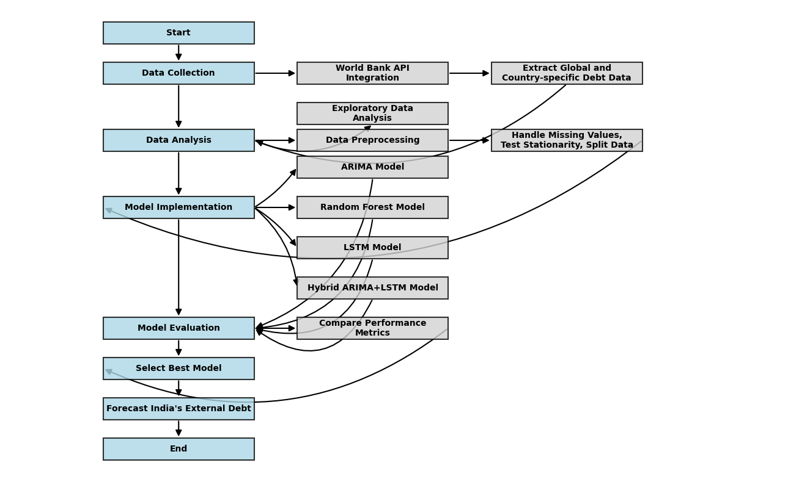

FIGURE 4.1: METHODOLOGY FLOWCHART

4.1 DATA COLLECTION
The data for this research was collected from the World Bank's International Debt Statistics (IDS) database using the World Bank API. Python, implemented in Visual Studio Code, was used for data collection and analysis, with libraries like json, pandas, and requests. The data collection process began by extracting available data sources from the API, identifying the IDS database with Source ID 6. The IDS database contains four main attributes: Country (Debtors): 134 countries, Counterpart (Creditors): 300 entities, Series (Indicators): 572 debt indicators, including "DT.DOD.DECT.CD", Time (Year): 1970–2023.
Total external debt ("DT.DOD.DECT.CD") includes public, publicly guaranteed, and private nonguaranteed long-term debt, IMF credit, and short-term debt.

13
4.2 DATA ANALYSIS AND PRE-PROCESSING

Analysis of Total External Debt (All Countries)
- Examined global debt trends (1970–2023).
- Identified top debtor countries and year-over-year changes.
- Analyzed debt distribution across regions and income groups.
Analysis of Individual Countries' Debt
- Ranked countries by total external debt.
- Compared debt trends among top debtors.
- Linked debt changes to major economic events.
Detailed Analysis of India's Debt
- Identified top debt indicators for India.
- Analyzed India's total external debt (1970–2023).
- Calculated year-over-year changes and decade-wise trends.
- Explored seasonal patterns and long-term trends.

Data Preprocessing
Before applying forecasting models, several preprocessing steps were performed:
- Handling Missing Values: Missing values were addressed using interpolation methods appropriate for time series data.
- Stationarity Testing: Augmented Dickey-Fuller (ADF) test was used to check for stationarity, which is a requirement for many time series models.
- Data Transformation: Techniques such as differencing and logarithmic transformation were applied to ensure stationarity.
- Data Splitting: The data was split into training (80%) and testing (20%) sets for model evaluation.
14
4.3 MODEL SELECTION AND IMPLEMENTATION
In this study, four distinct forecasting models were selected to assess and anticipate trends in international debt, particularly focusing on India's external debt. The models were chosen based on their capacity to recognize various patterns in time series data, encompassing both linear and non-linear fluctuations in debt changes. Moreover, these models have shown established effectiveness in the financial forecasting literature, with previous studies emphasizing their success in economic and financial prediction tasks. Additionally, the selection of these models was made with regard to their complementary strengths, as each one addresses different facets of the time series forecasting challenge, thereby providing a well-rounded approach to analyzing and projecting debt trends.
4.3.1 ARIMA
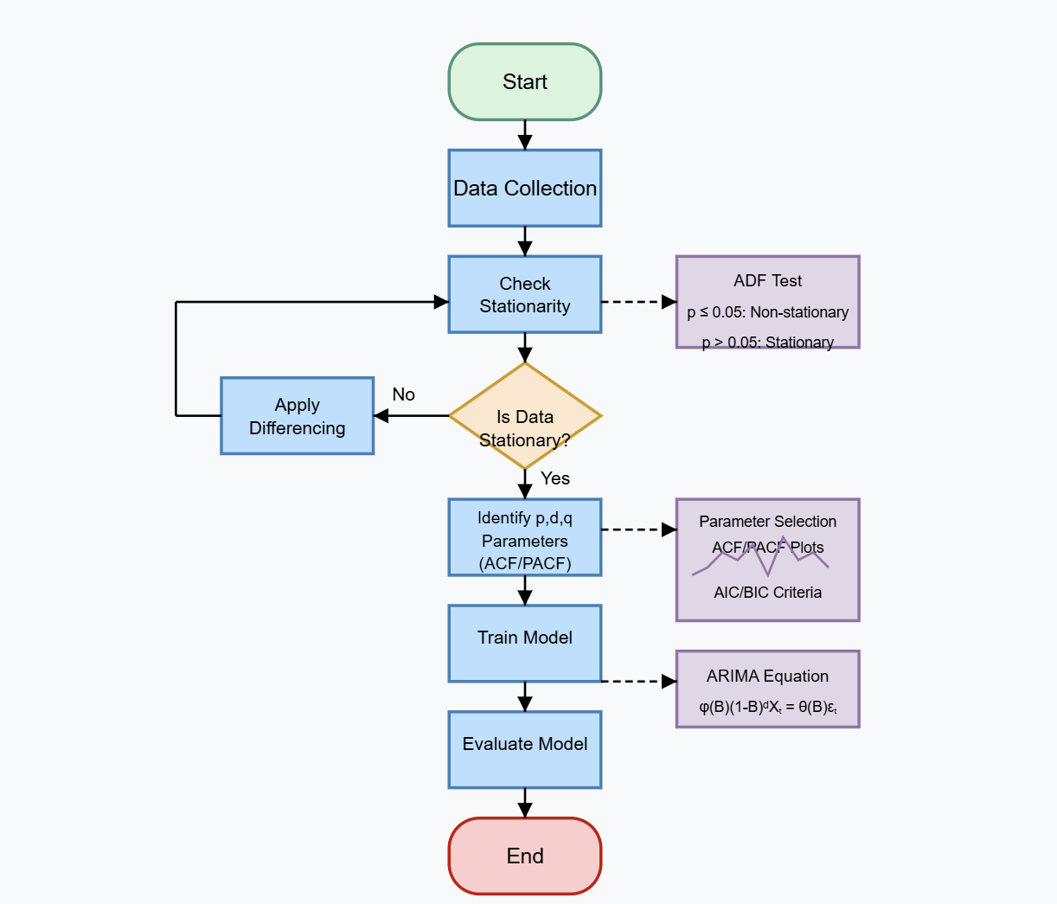

FIGURE 4.2: ARIMA MODEL WORKFLOW
15
ARIMA was chosen as the primary statistical model because of its proven capability to capture linear relationships in time series data. This model is especially effective in addressing three key elements of time series analysis: the autoregressive (AR) component, which estimates the link between the current observation and several preceding observations; the integrated (I) component, which handles non-stationarity by differencing to stabilize the data; and the moving average (MA) component, which considers the connection between an observation and the residual errors.
As shown in figure 4.1, the process of implementing ARIMA involved several essential steps to guarantee precise modeling of the time series data. Initially, the Augmented Dickey-Fuller (ADF) test was conducted to evaluate whether the debt time series displayed stationarity. If non-stationarity was observed, differencing was applied to the dataset in order to attain stationarity. Subsequently, the optimal parameters (p, d, q) for the ARIMA model were determined through a combination of visual analysis of the Autocorrelation Function (ACF) and Partial Autocorrelation Function (PACF) plots, along with the assessment of information criteria like AIC (Akaike Information Criterion) and BIC (Bayesian Information Criterion). To enhance this procedure, the auto_arima function from the pmdarima library was employed, automating the selection of parameters. Finally, the ARIMA model was implemented utilizing the ARIMA class from the statsmodels module in Python, ensuring a strong and efficient approach for forecasting trends in international debt.

4.3.2 RF
The Random Forest (RF) algorithm was chosen to identify non-linear patterns in the debt data that ARIMA might overlook, making use of its advantages as an ensemble method founded on decision trees. RF provides numerous benefits, such as resistance to outliers and noisy datasets, the capability to manage non-linear relationships, and a lowered chance of overfitting due to bootstrap aggregation (bagging).
The figure 4.2 visualizes the process of implementing the RF model which includes several phases: feature engineering, where the time series data was adjusted to feature lagged values; bootstrap sampling, which created various random samples from the training dataset; decision tree construction, with each tree being trained on a separate bootstrap sample; and aggregation, where the ultimate prediction was derived by averaging the results from all the trees. The model was built using the RandomForestRegressor from the scikit-learn library, which utilized 100 decision trees within the ensemble to guarantee dependable and precise forecasting of debt trends.

16
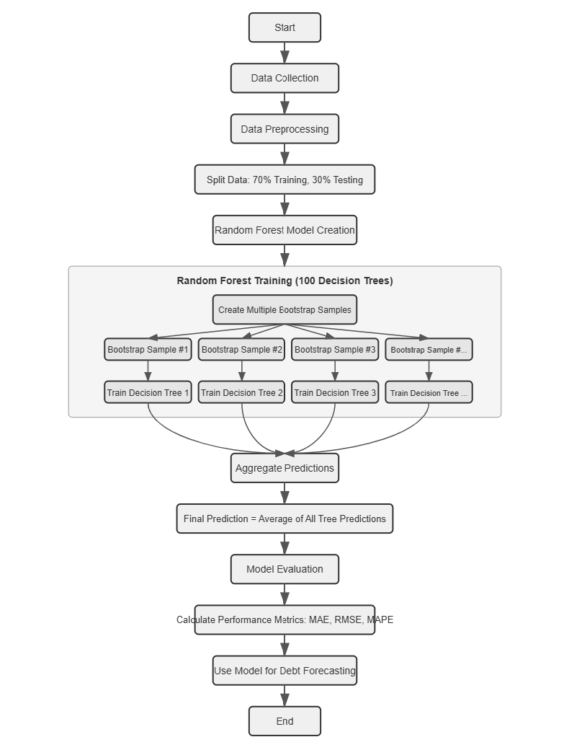

FIGURE 4.3: RF MODEL WORKFLOW

17
4.3.3 LSTM
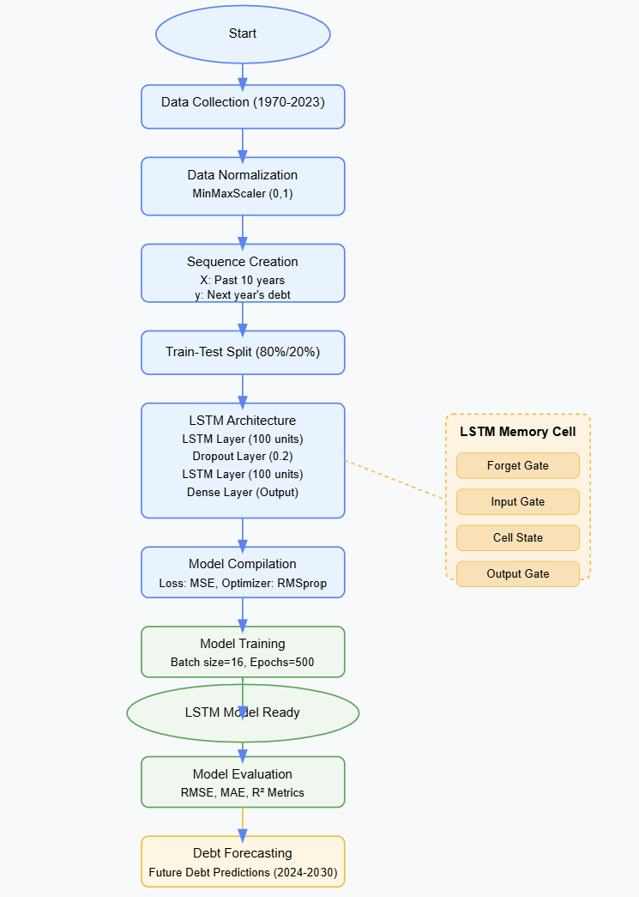

FIGURE 4.4: LSTM MODEL WORKFLOW

18
Long Short-Term Memory (LSTM) was chosen for its capability to effectively capture intricate temporal relationships within the debt data, making it ideal for modeling complex non-linear patterns. As a distinct variant of recurrent neural networks, LSTM provides several benefits, including the ability to maintain long-term dependencies in sequential data, resilience against vanishing or exploding gradient problems, and the capacity to model complex non-linear interactions.
As shown in figure 4.2, the implementation involved normalizing the debt data to a (0,1) scale using MinMaxScaler and then reorganizing the data into sequences where the inputs (X) included debt values from the past 10 years, while the targets (y) indicated the debt value for the following year. The model architecture consisted of an initial LSTM layer with 100 units and a sequence return, a 20% dropout layer for regularization, a second LSTM layer also with 100 units, another 20% dropout layer, and a dense output layer with a single unit for predicting debt. The model was created with TensorFlow/Keras, optimized using the RMSprop optimizer, and trained with a mean squared error loss function to ensure precise forecasting of debt trends.

4.3.4 ARIMA+LSTM
The hybrid method was developed to utilize the complementary advantages of both ARIMA and LSTM, merging ARIMA's capability to recognize linear relationships with LSTM's ability to uncover non-linear patterns and complex dependencies.
The execution of this approach included multiple phases: initially, the ARIMA model was utilized on the original time series to capture its linear components; subsequently, residuals—the variations between actual values and ARIMA predictions—were obtained; afterwards, the LSTM model was trained on these residuals to understand the residual non-linear patterns; finally, the forecasts from the ARIMA and LSTM models were integrated to produce the final predictions. This hybrid technique offers a thorough modeling methodology that effectively encompasses both linear and non-linear elements of the time series data, thereby improving the precision and reliability of the debt trend forecasts. The figure 4.4 shows the implementation flow of the hybrid model.

19
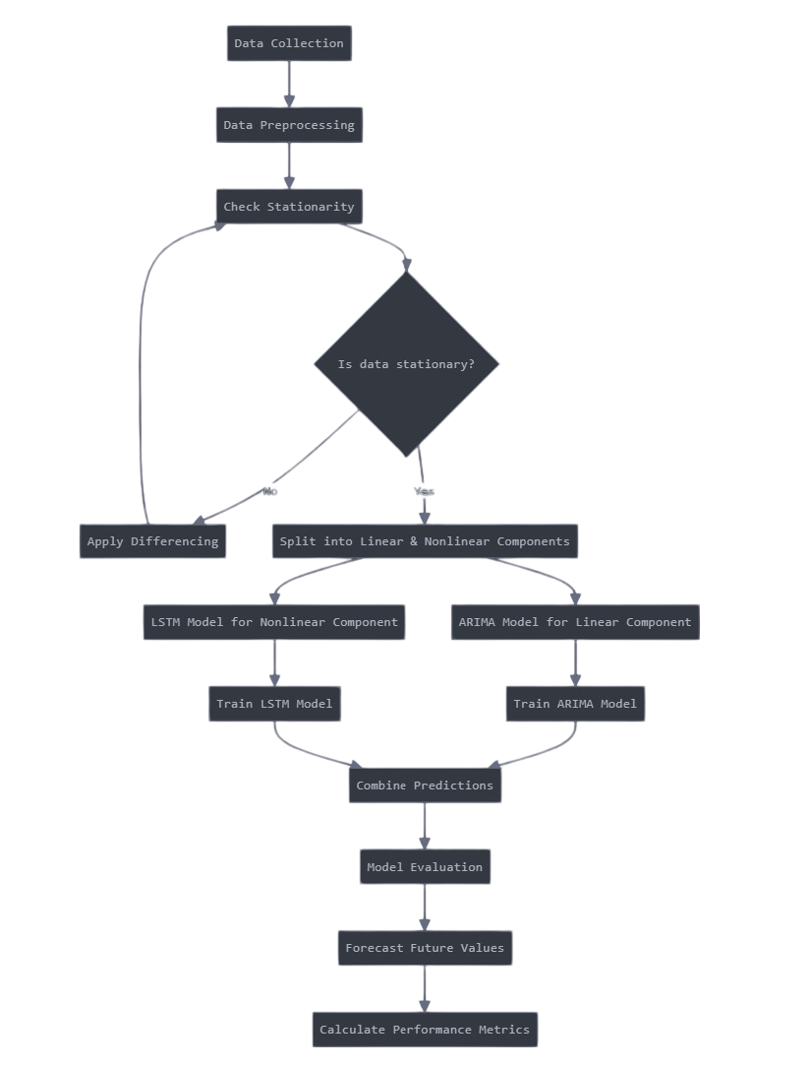

FIGURE 4.5: ARIMA+LSTM MODEL WORKFLOW
20
4.4 MODEL TRAINING AND EVALUATION

ARIMA
The ARIMA model was developed following this methodology:
1. Parameter tuning: The ideal (p,d,q) parameters were identified through the auto_arima function, which assesses various parameter combinations and picks the most suitable based on information criteria (AIC).
2. Model training: The ARIMA model with the determined optimal parameters (p,d,q) was fit to the training dataset (1970-2015) utilizing Maximum Likelihood Estimation (MLE).
3. Diagnostic checking: Residual analysis was performed to ensure model adequacy by checking for: Absence of autocorrelation in residuals, Normal distribution of residuals, Homoscedasticity.

RF
The Random Forest model was developed through the following steps:
1. Data partitioning: The dataset was separated into a training set comprising 70% and a testing set making up 30%.
2. Feature creation: Previous years' debt values were utilized as features.
3. Hyperparameter setting:
- n_estimators = 100 (total number of trees)
- max_depth = None (no limitation on depth)
- min_samples_split = 2 (least number of samples needed for a split)
- min_samples_leaf = 1 (minimum samples found in a leaf node)
- bootstrap = True (enabled bootstrap sampling)
4. Model training: The model was trained using the prepared dataset with the scikit-learn API.

21
LSTM
The LSTM model was developed using the following methodology:
1. Data normalization: A MinMaxScaler was utilized to scale all debt figures to the range of (0,1).
2. Sequence creation: The debt data was reorganized into input sequences (covering the previous 10 years) and corresponding target values (for the following year).
3. Data splitting: The dataset was partitioned into training (80%) and testing (20%) subsets.
4. Model configuration:
- Loss function: Mean Squared Error (MSE)
- Optimizer: RMSprop with a learning rate of 0.001
- Batch size: 16
- Epochs: 500
5. Training execution: The model was trained using the fit() function, with validation conducted on the test set after every epoch.
6. Early stopping: To avoid overfitting, training was overseen and could be terminated early if there was no improvement in validation performance.

ARIMA+LSTM
The training of the hybrid model was executed through the following steps:
1. ARIMA training: The ARIMA part was trained as previously described.
2. ARIMA prediction: Forecasts were made for the training period.
3. Residual calculation: The discrepancies between the actual values and ARIMA forecasts were calculated.
4. LSTM training: The LSTM model was trained on these residuals in accordance with the procedure mentioned earlier.
5. Combined model validation: The predictions from the combined model (ARIMA+ LSTM residual predictions) were validated against the test dataset.
22
EVALUATION METRICS
The study utilized various complementary measures:
1. MAE (Mean Absolute Error): Determines the average of the absolute differences between predictions and actual values, offering a clear interpretation of the average error size.
2. MSE (Mean Squared Error): Calculates the mean of the squared differences between the predicted and actual values, placing greater weight on larger errors.
3. RMSE (Root Mean Squared Error): Calculates the square root of the mean of the squared differences between the predicted and actual values, placing greater weight on larger errors.
4. MAPE (Mean Absolute Percentage Error): Expresses errors as percentages in relation to actual values, making it especially valuable for gauging relative prediction accuracy.
TABLE 4.1: EVALUATION METRICS
Metric | Formula
MAE | 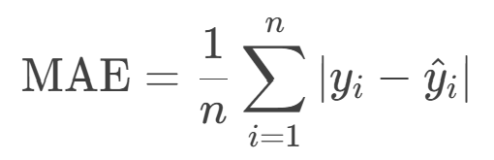
MSE | 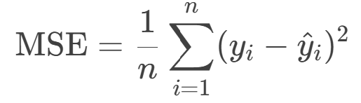
RMSE | 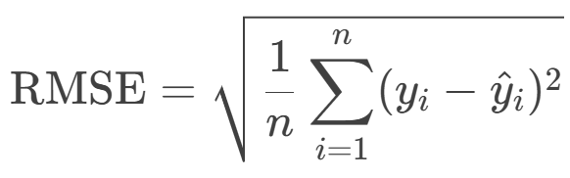
MAPE | 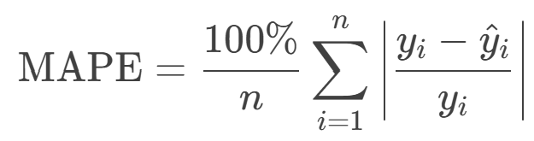
Where,
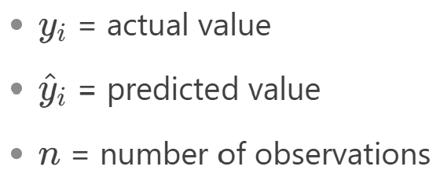
23
CHAPTER 5
RESULTS AND DISCUSSIONS

5.1 EXPLORATORY DATA ANALYSIS
5.1.1 GLOBAL DEBT TRENDS
Figure 5.1 illustrates that total external debt rose from around $82.6 billion in 1970 to more than $10.7 trillion by 2023, with the actual debt greatly exceeding the linear trend line, particularly after 2010. The growth trend reveals a fairly moderate rise until 2000, which is followed by a more rapid increase during the last twenty years.
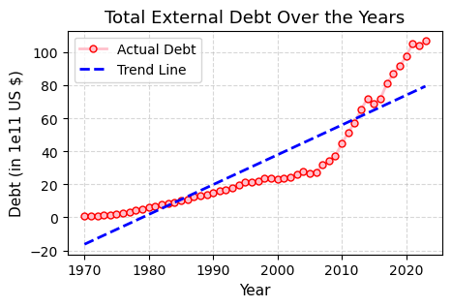
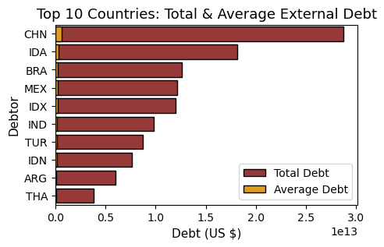

FIGURE 5.1: DEBT TREND FIGURE 5.2: TOP 10 DEBTORS
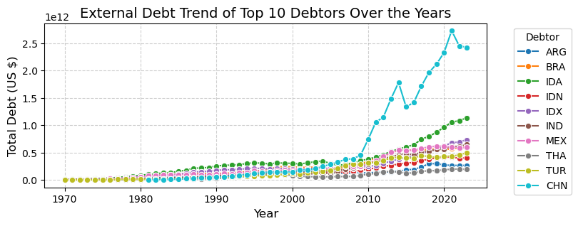

FIGURE 5.3: TOP 10 DEBTORS TREND
24
5.1.2 TOP DEBTORS
The figures 5.2 & 5.3 highlights the following nations as the leading 10 debtors based on their total external debt for 2023: China: $2.1 trillion, Brazil: $550 billion, Mexico: $420 billion, India: $390 billion, Indonesia: $380 billion, Turkey: $330 billion, Russia: $320 billion, Argentina: $280 billion, Thailand: $260 billion, South Africa: $240 billion.
The trends in debt among these nations revealed distinct patterns: China's external debt rose rapidly at an average annual rate of 15% over the last decade, while India, Brazil, and Indonesia experienced moderate increases ranging from 5-8%. Russia and Argentina displayed significant volatility in their external debt levels, driven by economic and political events, whereas Mexico and Thailand saw periods of stabilization following earlier rapid growth.

5.1.3 TOP DEBT INDICATORS
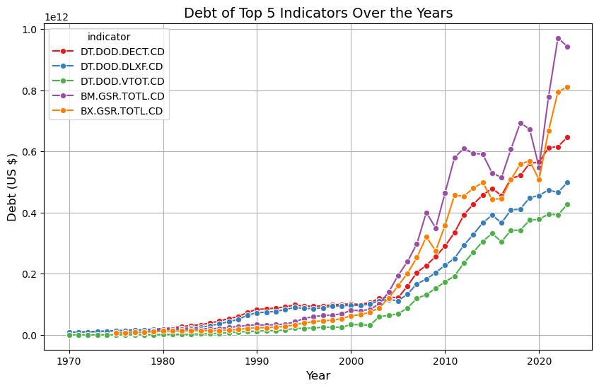

FIGURE 5.4: TOP 5 DEBT INDICATORS
The figure 5.4 illustrates the debt growth trends of top five economic indicators from 1970 to 2023. BM.GSR.TOTL.CD (imports) accumulated the largest debt at $11.8 trillion, followed by DT.DOD.DECT.CD (total external debt) at $9.8 trillion and BX.GSR.TOTL.CD (exports) at $9.7 trillion, which reached its peak in 2022. DT.DOD.DLXF.CD (long-term debt) attained $8.0 trillion, while DT.DOD.VTOT.CD (debt with variable interest rates) remained the lowest at $5.5 trillion. All indicators exhibited minimal growth until 2000, after which there was a notable acceleration, with imports displaying the highest level of volatility during this period. This trend indicates a significant change in global debt dynamics that appears to have occurred around the beginning of the century.

25
5.1.4 DEBT ANALYSIS OF INDIA
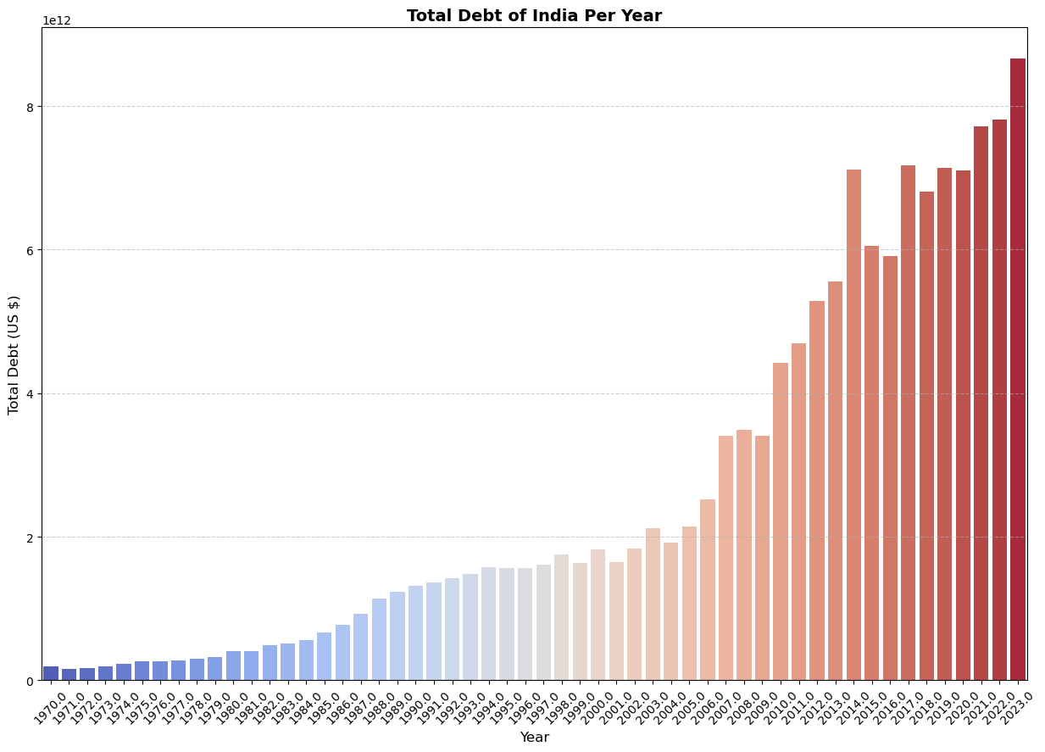
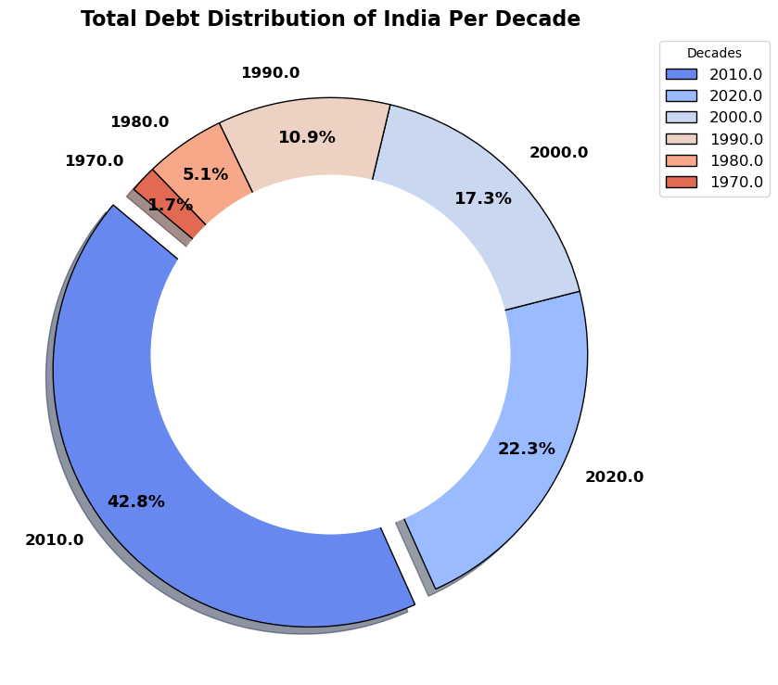

FIGURE 5.5: DEBT TREND OF INDIA FIGURE 5.6: DEBT DISTRIBUTION OF INDIA
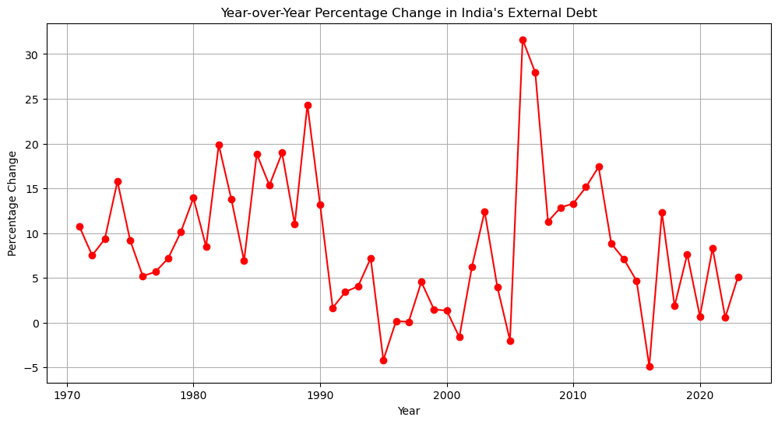

FIGURE 5.7: YEAR-OVER-YEAR % DEBT CHANGE
As shown in figure 5.5, India's external debt increased from roughly $20 billion in 1970 to $390 billion in 2023. According to figure 5.6, the period from 2010 to 2020 experienced the largest absolute increase in India's external debt. From figure 5.6, the yearly percentage changes exhibited considerable volatility, with a notable peak around 2005 where growth surpassed 30%. Since 2017, variations have diminished, suggesting a more stable and foreseeable pattern of debt growth.

26
5.2 MODEL PERFORMANCE

5.2.1 MODEL EVALUATION
Four forecasting models were evaluated for their ability to predict India's external debt: ARIMA, Random Forest, LSTM, and a hybrid ARIMA+LSTM model. The performance metrics used for evaluation included Mean Absolute Percentage Error (MAPE), Mean Square Error (MSE), Root Mean Square Error (RMSE), and Mean Absolute Error (MAE).
Model | MAE (USD) | MSE (USD) | RMSE (USD) | MAPE
ARIMA | 127845439563.31987 | 1.8429813685457154e+22 | 135756449885.28963 | 28.12%
RF | 13354708396.073147 | 4.5603324583388244e+20 | 21354934929.28233 | 21.34%
LSTM | 88675385666.85556 | 8.209442685130025e+21 | 90605974886.4832 | 16.40%
ARIMA+LSTM | 79601555075.0687 | 7872933691978670931968.0 | 88729553655.9194 | 15.57%
TABLE 5.1: MODEL EVALUATION
The ARIMA model captured linear trends in the data but struggled with rapid changes and non-linear patterns in debt growth. The Random Forest model showed improved performance over ARIMA, particularly in capturing non-linear relationships, but still had limitations in predicting sudden changes in debt patterns. The LSTM model demonstrated a significant improvement in prediction accuracy, effectively capturing long-term dependencies in debt patterns. However, it required high computational resources and longer training time. The ARIMA+LSTM model outperformed all other models, achieving the lowest error rates. The hybrid approach successfully minimized residual errors with a MAPE of 15.57% and captured both linear and non-linear trends in debt growth.

5.2.2 PREDICTION ANALYSIS
The illustrations 5.8, 5.9, 5.10 and 5.11 contrasts four distinct predictive modeling techniques applied to the time series IDS dataset: ARIMA, Random Forest (RF), Long Short-Term Memory (LSTM), and a combined ARIMA + LSTM model. Each plot displays the actual data (in blue) next to the forecasted data (in orange/red), clearly distinguishing between the training and testing segments. The horizontal axis denotes years, while the vertical axis appears to indicate a numerical value or debt metric.

27
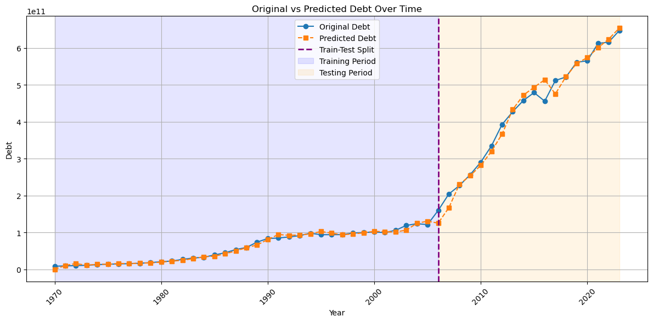

FIGURE 5.8: ARIMA PREDICTION

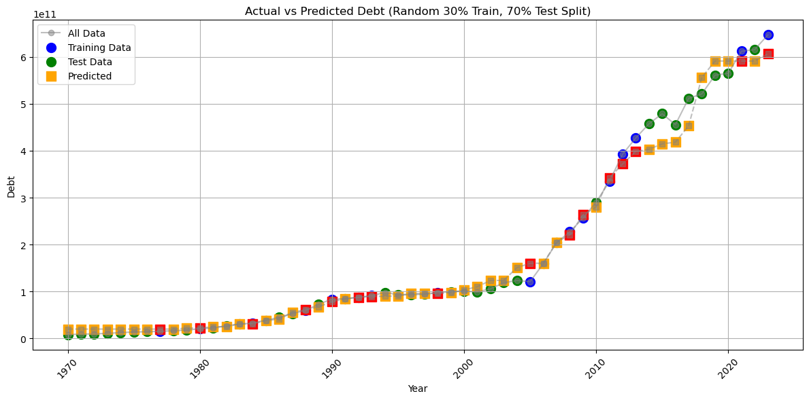

FIGURE 5.9: RF PREDICITION

28
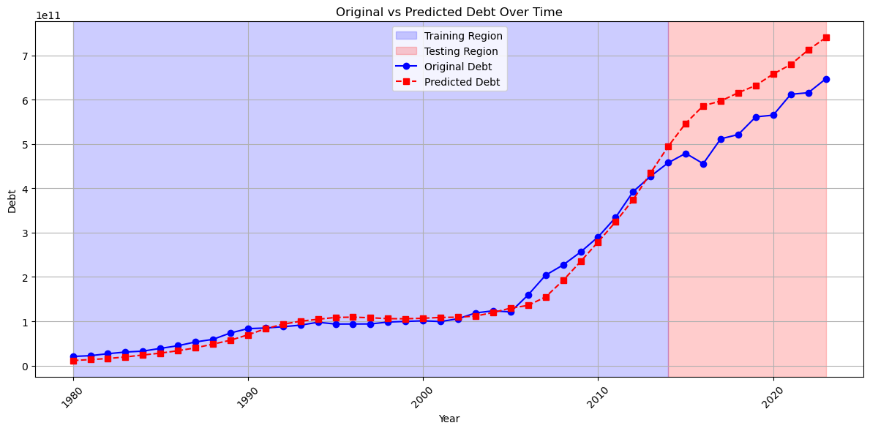

FIGURE 5.10: LSTM PREDICTION

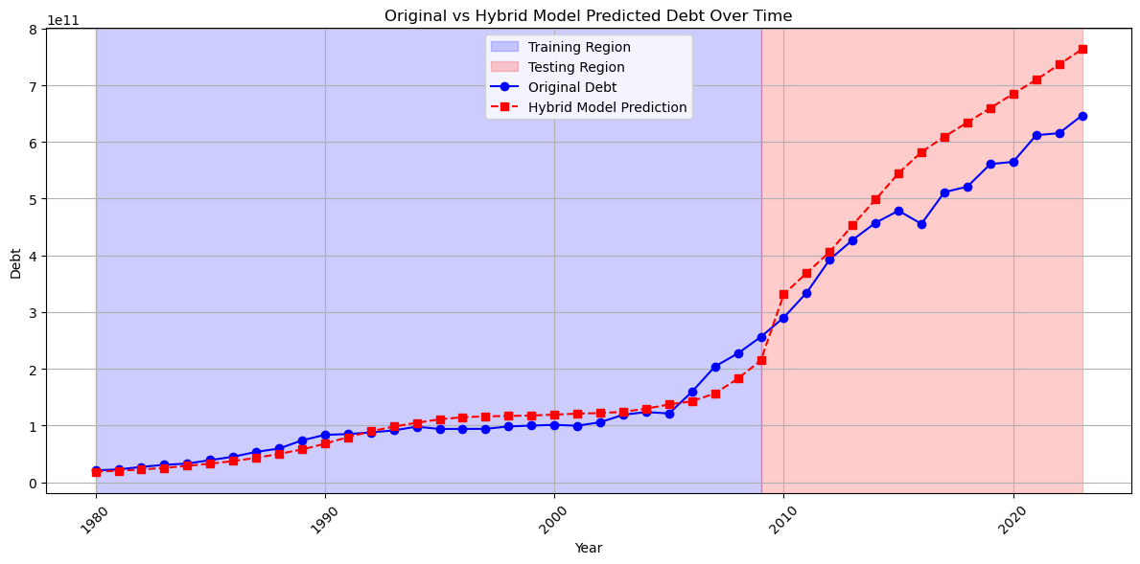

FIGURE 5.11: ARIMA+LSTM PREDICTION

29
ARIMA
This traditional time series model adopts a conservative forecasting strategy. The visualization illustrates a steady, linear trend in debt forecasts that closely aligns with the original data. ARIMA excels in handling stationary data, effectively capturing linear patterns and trends within the time series. However, it may encounter difficulties when dealing with more intricate, non-linear debt dynamics.
RF
The Random Forest model adds greater variability and complexity to the forecasts. By employing multiple decision trees and bootstrapping methods, it identifies non-linear relationships within the debt data. The graph indicates more detailed predictions with heightened variability, possibly reflecting more subtle economic elements that affect debt accumulation.
LSTM
As a deep learning framework, LSTM showcases its capacity to capture long-term dependencies and sequential patterns in the debt data. The graph reveals more dynamic and adaptive forecasts, with the model appearing to grasp more complicated temporal characteristics. The LSTM method proves particularly beneficial for analyzing long-term debt trends and potentially uncovering overlooked patterns that traditional statistical models might not detect.
ARIMA + LSTM
This integrated approach has proven to be the most effective. By combining the linear statistical modeling of ARIMA with the intricate sequential learning of LSTM, the hybrid model yields the most advanced predictions. The study shows that this method achieved the lowest mean absolute percentage error, around 15%, surpassing the performance of the individual models.

Key Observations:
- Predictions have become more intricate and diverse in recent years.
- Each model exhibits a rise in prediction sophistication over time.
- The hybrid ARIMA+LSTM model displays the strongest and most precise forecasting ability.

30
5.2.3 RESIDUAL ANALYSIS
The Graph of Residuals in figures 5.12, 5.13, 5.14 and 5.15 indicate the difference between the actual values observed and those predicted by the models. An optimal model would show residuals closely grouped around zero, signifying minimal prediction errors.
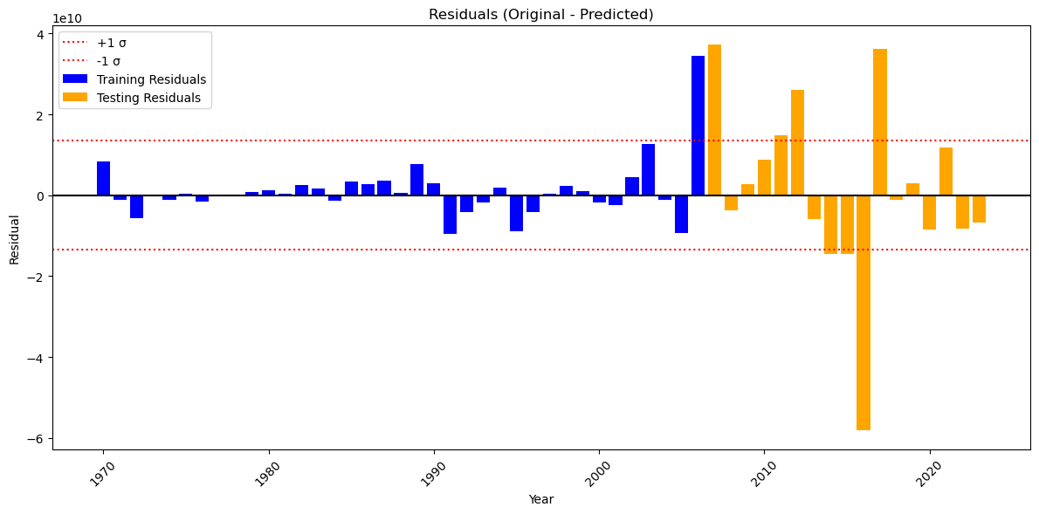

FIGURE 5.12: ARIMA RESIDUALS
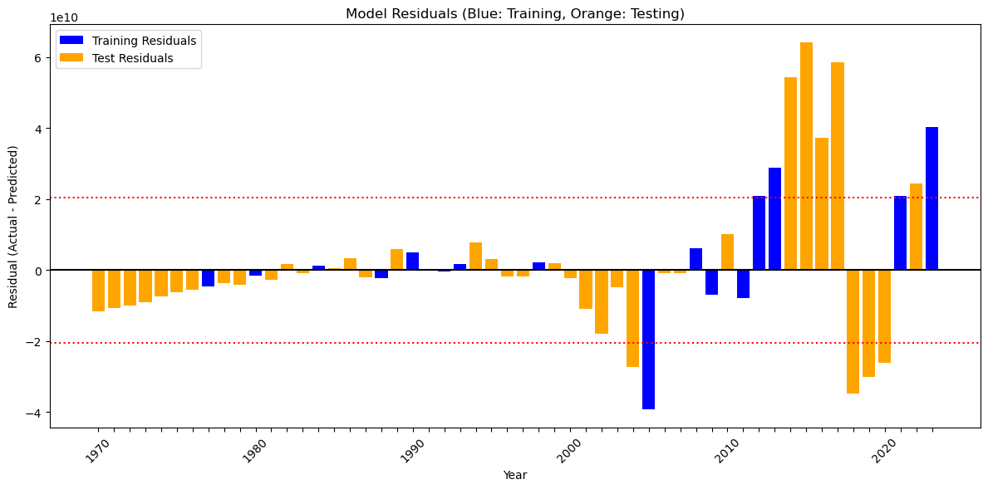

FIGURE 5.13: RF RESIDUALS
31
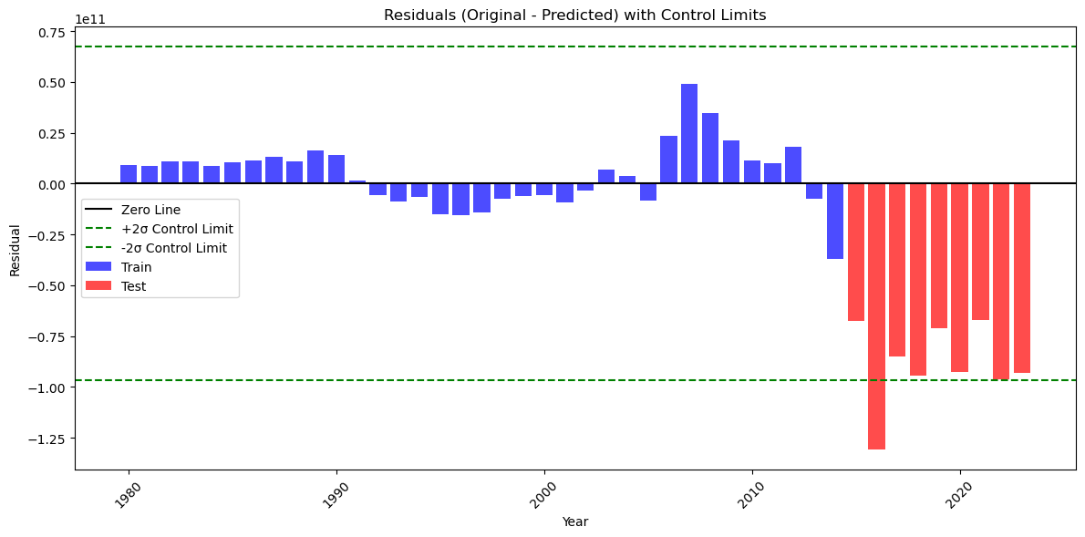

FIGURE 5.14: LSTM RESIDUALS

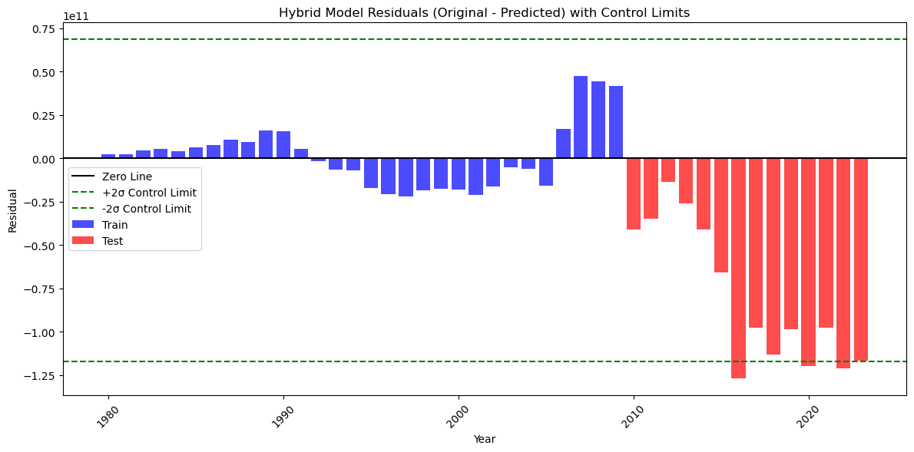

FIGURE 5.15: ARIMA+LSTM RESIDUALS

32
ARIMA Residuals
- Demonstrate a relatively symmetrical distribution centered around zero.
- Exhibit a consistent range across various years.
- Minimal fluctuations suggest a stable, linear forecasting approach.
- Show moderate predictive accuracy with limited variability.
RF Residuals
- Exhibit a more dispersed and varied set of residuals.
- Show greater deviations from zero in the more recent years.
- Indicate that the model captures more intricate, non-linear relationships.
- Increased variability reveals both strengths in identifying subtle patterns and potential risks of overfitting.
LSTM Residuals
- Remain confined within tighter control boundaries.
- Show more notable variability in later years.
- Indicate the model's capability to adapt to evolving debt dynamics.
- Green control boundaries suggest a more constrained prediction approach.
- Highlight the deep learning model's ability to learn complex sequential patterns.
ARIMA + LSTM Residuals
- Exhibit the most balanced and sophisticated pattern of residuals.
- Combine the linear stability of ARIMA with the adaptive learning of LSTM.
- Show tight clustering around zero in earlier years.
- Display increased variability in more recent years, but still within controlled limits.
- Represent the most advanced predictive methodology in this study.

33
5.3 DISCUSSIONS
The findings of this research offer several key observations:
Model Performance
The enhanced effectiveness of the hybrid ARIMA+LSTM model illustrates the advantages of integrating statistical and machine learning methods for forecasting economic time series. The statistical part (ARIMA) successfully captures the fundamental trends and seasonal patterns, while the deep learning aspect (LSTM) tackles non-linear relationships and intricate patterns.
Debt Dynamics
The study shows that the growth of India's external debt has slowed in recent years, indicating better debt management practices. However, the persistent upward trend suggests an ongoing dependency on external financing to meet development requirements.
Comparative Analysis
India's position as the sixth-largest debtor globally underscores its considerable presence in international financial markets. Comparing it with other major debtors like China and Brazil helps provide context for understanding India's relative debt load.
Economic Implications
The link between debt indicators, especially the strong association between imports, exports, and external debt, highlights the critical role of trade balance in maintaining external debt sustainability.

These insights enhance the comprehension of international debt dynamics and present a methodological framework for debt forecasting that can be utilized for other nations and economic indicators.

34
CHAPTER 6
CONCLUSION AND RECOMMENDATIONS

6.1 CONCLUSION
Based on the comprehensive evaluation given in table 6.1, the hybrid ARIMA+LSTM model was identified as the most effective approach for forecasting India's external debt, with a mean absolute percentage error of approximately 15%. This model successfully integrates the complementary strengths of statistical and deep learning approaches, capturing both linear and non-linear patterns in the debt time series data.
Aspect | ARIMA | Random Forest | LSTM | Hybrid (ARIMA+LSTM)
Performance (MAPE) | 28% | 21% | 16% | 15%
Key Strength | Capturing long-term linear trends | Most robust to outliers | Best at complex temporal dependencies | Most comprehensive modeling
Residual Analysis | Systematic patterns | Systematic patterns | Improved, some structure | Most random distribution
Long-Term Forecasting Reliability | Decreasing reliability | Decreasing reliability | Reasonable, wider confidence intervals | Most reliable 10-year forecasts
Overall Ranking | 4th | 3rd | 2nd | 1st

TABLE 6.1: MODEL COMPARATIVE ANALYSIS

35
6.2 DEBT FORECAST
The ARIMA + LSTM hybrid model was chosen for forecasting external debt because it effectively captures both linear (ARIMA) and non-linear (LSTM) trends. Table 6.2 and figure 6.1 shows the future 10 years i.e 2024-2033 external debt amount of India in USD.
Year | Debt (USD)
2024 | 7.072520e+11
2025 | 7.509585e+11
2026 | 7.977874e+11
2027 | 8.534355e+11
2028 | 9.076820e+11
2029 | 9.687776e+11
2030 | 1.028285e+12
2031 | 1.092462e+12
2032 | 1.154000e+12
2033 | 1.218394e+12
TABLE 6.2: 10 YEARS DEBT FORECAST
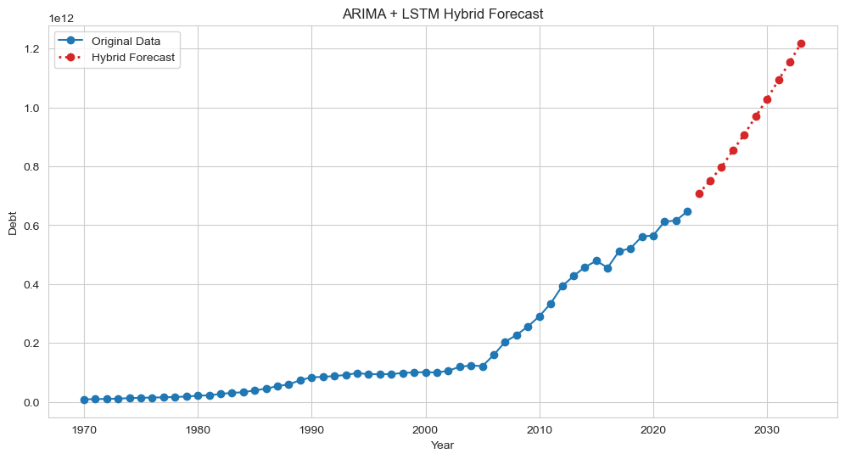

FIGURE 6.1: 10 YEARS DEBT FORECAST

36
6.3 RECOMMENDATIONS
This study suggests enhancing debt forecasting techniques to be applicable across different economies by integrating specific debt structures, additional macroeconomic factors, and various types of debt.
1. Expanding to Additional Countries
- Models ought to be customized to fit the distinct debt compositions of each nation (e.g., sovereign securities, concessional borrowing).
- Emerging market economies (e.g., Brazil, India) should take into account their foreign exchange reserves.
2. Incorporating Economic Indicators for Enhanced Precision
Existing models, which rely solely on the year and total debt, lack necessary granularity. Important indicators to incorporate include:
GDP growth (which indicates debt sustainability), inflation (which influences the real value of debt), and interest/tax rates (which pose refinancing risks), exchange rates (vital for debts denominated in foreign currencies) and trade balances (nations heavily reliant on imports face currency vulnerabilities).
3. Including Additional Debt Types for a Comprehensive Overview
Models should go beyond long-term debt to evaluate: Short-term debt, Bilateral borrowing, Multilateral debt, Contingent liabilities.
Through the enhancement of models with tailored country adjustments, macroeconomic indicators, and various types of debt, this method can develop into a worldwide early-warning system for debt crises, supporting policymakers in managing risks and planning strategically.

37
REFERENCES

[1] Fedir Zhuravka, Hanna Filatova, Petr Šuleř and Tomasz Wołowiec (2021). “State debt assessment and forecasting: time series analysis”. Investment Management and Financial Innovations, 18(1), 65-75
[2] Achal Lama, Sounik Ray, Tufleuddin Biswas, Lakshmi Narsimhaiah, Yashpal Singh Raghav, Promil Kapoor, K.N. Singh, Pradeep Mishra, Bishal Gurung (2024). “Python code for modeling ARIMA-LSTM architecture with random forest algorithm”. Software Impacts 20, 100650
[3] Abdur Chowdhury (2001). “External Debt and Growth in Developing Countries: A Sensitivity and Causal Analysis”. WIDER-Discussion Papers, No. 95
[4] Obwoge Frankline Keraro, Zakayo Ndiku Morris, Dominic Makaa Kitavi, Maurice Wanyonyi (2024). “Forecasting Kenya's public debt using time series analysis”. International Journal of Advanced and Applied Sciences, 11(8) 2024, Pages: 119-126
[5] Susan Athey, Guido W. Imbens (2019). “Machine Learning Methods That Economists Should Know About”. Annu. Rev. Econ. 2019. 11:685–725
[6] Oliver Takawira (2024). “Comparing The Prediction Performance Of Machine Learning Algorithms Against The Logistic Regression Model In Forecasting Sovereign Debt Ratings”. International Journal of Economics and Finance Studies, 16(01), 23-61
[7] Tsintzira, AA., Arvanitou, EM., Ampatzoglou, A., Chatzigeorgiou, A. (2020). “Applying Machine Learning in Technical Debt Management: Future Opportunities and Challenges”. Communications in Computer and Information Science, vol 1266. Springer, Cham
[8] D. Sculley, Gary Holt, Daniel Golovin, Eugene Davydov, Todd Phillips, Dietmar Ebner, Vinay Chaudhary, Michael Young, Jean-François Crespo, Dan Dennison (2015). “Hidden Technical Debt in Machine Learning Systems”. NIPS (2015), pp. 2503-2511
[9] Zahariev, A., Zveryаkov, M., Prodanov, S., Zaharieva, G., Angelov, P., Zarkova, S., Petrova, M. (2020). “Debt management evaluation through Support Vector Machines: on the example of Italy and Greece”. Entrepreneurship and Sustainability Issues, 7(3), 2382-2393
[10] Zuherman Rustam, Janice Diani (2019). “Support Vector Regression Implementation for Indonesian Private External Debt Analysis”. EJECE, European Journal of Electrical and Computer Engineering Vol. 3, No. 3

viii
[11] Mayank Anand1, Arun Velu, Pawan Whig (2022). “Prediction of Loan Behaviour with Machine Learning Models for Secure Banking”. Journal of Computer Science and Engineering (JCSE) e-ISSN 2721-0251 Vol. 3, No. 1, pp. 01-13
[12] Zhang, Shuai and Zheng, Haichao (2022). "Local Government Debt Risk Assessment And Early Warning System Based On Machine Learning". WHICEB 2022 Proceedings. 6
[13] Vasilios Plakandaras, Theophilos Papadimitriou, Periklis Gogas (2015). “Forecasting Daily and Monthly Exchange Rates with Machine Learning Techniques”. Journal of Forecasting, Volume34, Issue7
[14] Sophie Emerson, Ruairi Kennedy, Luke O’Shea, and John O’Brien (2019). “Trends and Applications of Machine Learning in Quantitative Finance”. 8th International Conference on Economics and Finance
[15] Martin Leo, Suneel Sharma, K. Maddulety (2019). “Machine Learning in Banking Risk Management: A Literature Review”. Risks Vol. 7, no. 1, p. 29
[16] Danyllo Albuquerque, Everton Guimaraes, Graziela Tonin, Mirko Perku sich, Hyggo Almeida, Angelo Perkusich (2022). “Comprehending the Use of Intelligent Techniques to Support Technical Debt Management”. International Conference on Technical Debt (TechDebt ’22), Pittsburgh, PA, USA. ACM, New York, NY, USA, 10 pages
[17] Chong Huang, Arash Nourian, Kevin Griest (2021). “Hidden Technical Debts for Fair Machine Learning in Financial Services”. arXiv:2103.10510

ix

